

COSC 2200 – Object-Oriented Programming 3  
 Abdulla Hammad

Deliverable 3: Application Design and Data Specification

REPORT DONE BY

**Sheizah Jimenez | 100892505**  
 **Raisa Nasara | 100887894**  
**Hlib Marchenko | 100901448**  
 **Zhanibek Kapen | 100861891**

# SYSTEM ARCHITECTURE AND ASSETS

## Preview version of game UI

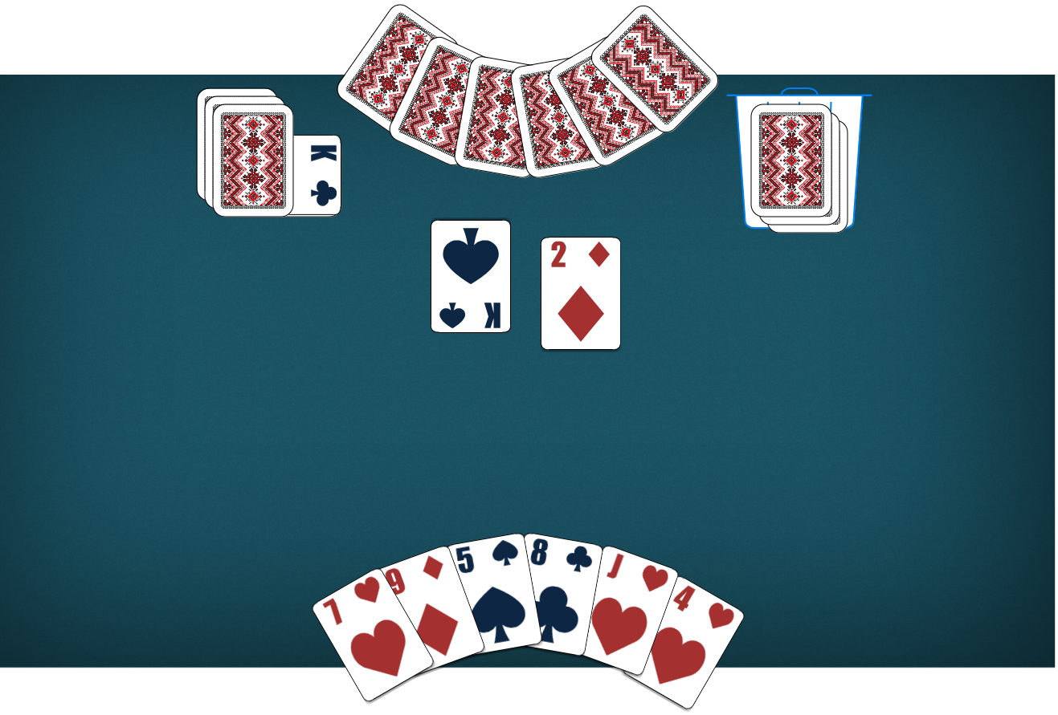*Made by Hlib Marchenko from free and open-source assets

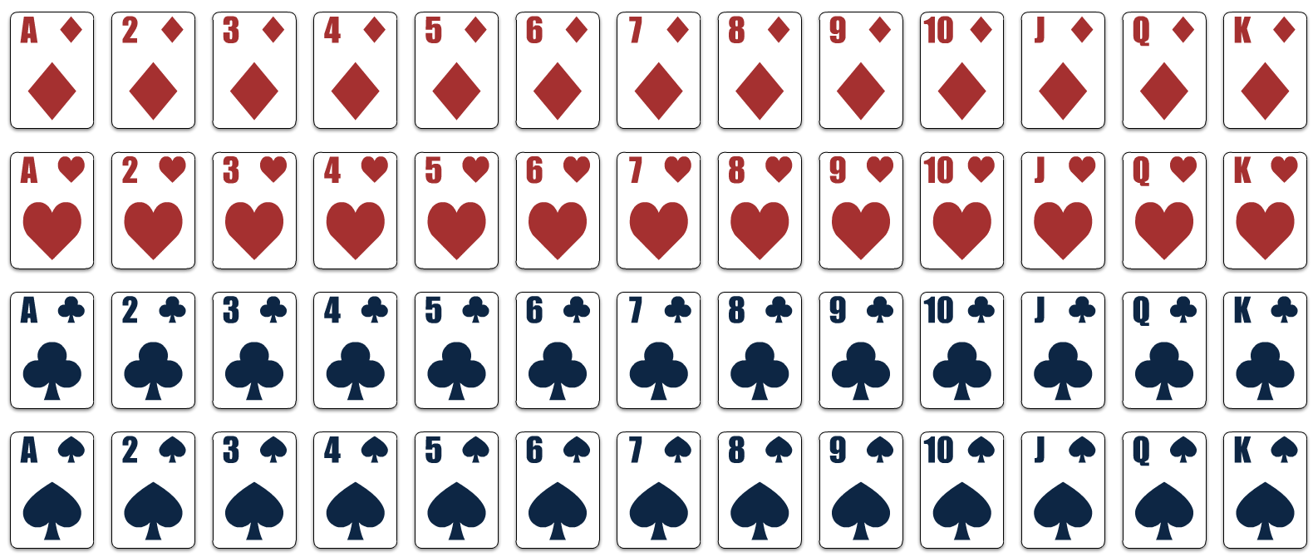

Assets used:

* Card Asset Pack by [natomarcacini](https://natomarcacini.itch.io/card-asset-pack)
* Delapouite by [Game-icons.net](https://game-icons.net/1x1/delapouite/cyborg-face.html#download)

# CLASS DIAGRAM

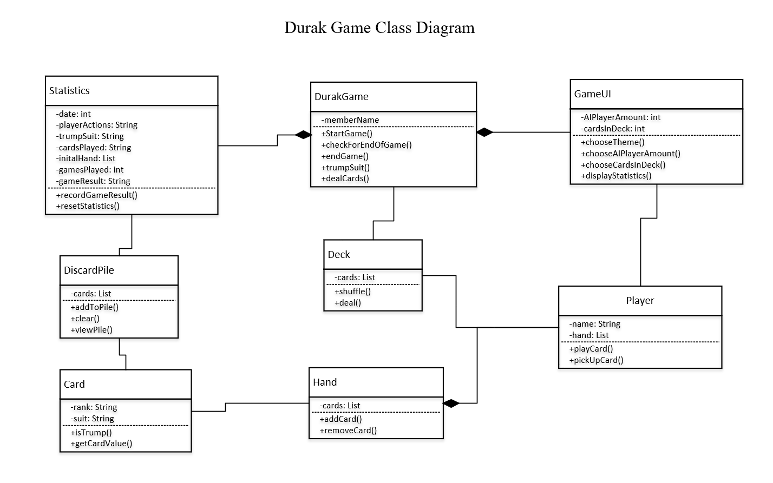

# DATA STRUCTURES AND DATA FLOW

## Proposed Data Structures

Considering our group’s project will be based around the card game *Durak*, it would be beneficial to have the following data structures:

* **Game Data Logging**. While a game is running, we will want to log who is currently attacking/defending, the winner/loser, etc. This information is meant to be logged in a file with minimal security as this data will not change aspects of the game.
* **Player Data Logging**. During the application session, we will want to log a player’s overall wins, losses, score, number of games played, etc. This allows the player to keep track of how they are doing throughout each of their games by giving them insight on their playthroughs.
* **(Optional) Game Preferences**. If there is enough time for this project, we are also considering adding a game preferences menu where the player can change specific game settings or play certain game modes. THIS PART IS NOT CONSIDERED IN OUR DATA STRUCTURE CONSIDERATIONS SECTION.

## Data Structure Considerations

**GAME DATA STUCTURE**

|  |  |
| --- | --- |
| **Consideration** | **Proposal** |
| What type of data source will be used (flat file, JSON, XML, Relational database, no-sql database)? | For this particular data, we intend to use a flat file just to log how the game played out. |
| What are the fields, or objects, that will be stored in the data source? | * What trump card is. * Current turn. * Who is attacking/defending during turn. * Cards played during turn. * Winner/Loser of the turn. |
| What are the access permissions or other security considerations? | The player will only be able to access these files through the folders. Keeping the file on read-only for outsiders would protect this data sufficiently. |
| How is the file connected to, accessed, read, and written to from within the application? | Anytime one of the fields are updated, the information will be written into the file. Reading the file will only occur by opening the file within the project folder. |
| How are data sources linked to coded classes and how is OOP concepts maintained during data access? | We can utilize certain classes like Player to dictate when an action has occurred. From this, we can log the action into the file as long as it connects to our proposed fields. |
| How is the data stored within the project (generics, collections, ... etc.)? | As a basic txt file. |

**PLAYER DATA STUCTURE**

|  |  |
| --- | --- |
| **Consideration** | **Description** |
| What type of data source will be used (flat file, JSON, XML, Relational database, no-sql database)? | We intend to use JSON or XML for our project. Preferably using JSON for this type of data. |
| What are the fields, or objects, that will be stored in the data source? | * Overall wins/losses. * Number of games played. * Win-Lose ratio. Average win rate. * Total time played (optional). * Average time played (optional). |
| What are the access permissions or other security considerations? | The player will not be allowed to edit the information within these data files. Security measures such as keeping the file read-only for outsiders as well as internal error detection methods are essential for this data file. |
| How is the file connected to, accessed, read, and written to from within the application? | The GUI will interpret the data by ONLY reading the file information. |
| How are data sources linked to coded classes and how is OOP concepts maintained during data access? | We can save this information both inside of JSON file as well as the Player/NPC classes. This allows for more freedom on interpreting the data. |
| How is the data stored within the project (generics, collections, ... etc.)? | Collections. |

## Data Flow Diagrams

**GAME DATA: DATA FLOW DIAGRAM**

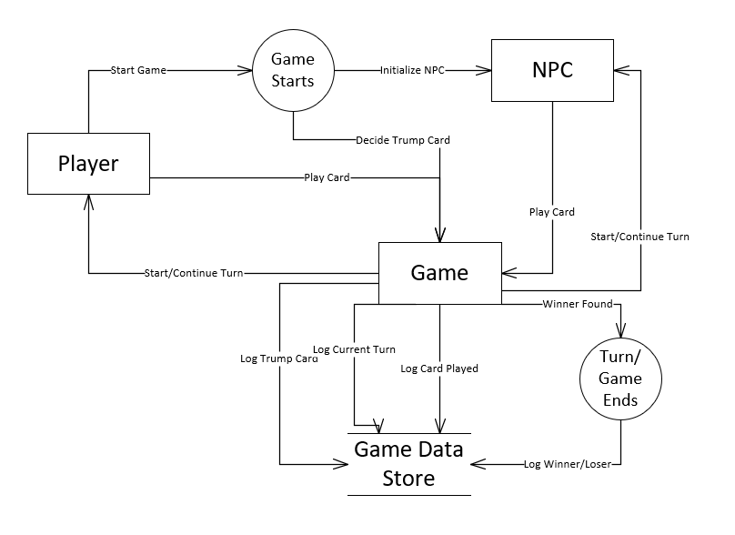

**PLAYER DATA: DATA FLOW DIAGRAM**

